

Name : WONG BOON PING

Login ID : R03412912@oasis-portal.my

Course title : Executive Diploma in Culinary Arts & Hospitality Management

Subject Code : CA03 International Cuisine

Submitted date: **07/Sept/ 2017**

**Table of Contents**

|  |  |  |
| --- | --- | --- |
| **No** | **Details** | **Page** |
| 1 | Executive Summary | 2 |
| 2 | Introduction | 3 - 4 |
| 3 | Assignment Question |  |
|  | Online Resource | 5 - 11 |
|  | Own Recipes | 12 - 17 |
| 4 | Conclusion | 18 |
| 5 | References | 19 |

**Executive Summary**

In this assignment we will learn about the purpose of this unit that is to be able to understand international cuisine within culinary Arts and Hospitality Management.

We will need to choose one dish from each cuisines. The cuisines are Chinese cuisines. Western cuisines and Indian cuisines. From each cuisines we will need to recreate or alter the original recipe into our own recipe.

By doing three different cuisine, I learn that each cuisine have their own recipe and cooking style. Indian cuisine is a favored flavor makers which most of the dishes with a lot of spices such as coriander, ginger, cumin, saffron and so on. Chinese cuisines are basics serve with rice and noodles. Moreover, meats and chilies are always a part of the dishes. Western cuisine are use potato as a main ingredient as well as wheat-flour bread, which those has become a major starch plant in the diet of western countries.

**Introduction**

International cuisine means is come from different countries and also refers to a cooking way that is practiced around the world. A cuisine is a characteristic style of cooking, including its practices, recipes, and traditions. Moreover, this could be used to promote a culture, specific region, and country. The aim of this paper is able to understand International Cuisine of Chinese, Indian, and Western Cuisine by creating own recipes, cooking method, and photos for illustration.

For example, Malaysia’s international cuisines are from:

**Japan cuisine**

1. Sushi
2. Teriyaki chicken
3. Rousing & egg bowl
4. Sukiyaki bowl
5. Teriyaki beef steak
6. Salt-Grilled Salmon
7. Tempura
8. Vinegared wakame & cucumbers
9. Boiled green soybeans

**Chinese cuisine**

1. Wealth and good fortune soup
2. Sweet potato soup
3. Lemon glazed prawns with vegetables
4. Braised mushrooms with fortune greens
5. Chicken ginger slice & onion
6. Yu sheng with knorr tom yam dressing
7. Stir fried chicken in green chilli
8. Beef and broccoli
9. Hot and spicy mala pot

**Korean cuisine**

1. Korean Spicy Beef and Daikon Soup
2. Yellow Fungus Chinese Yam and Maitake Mushroom Soup
3. Hasselback Potato
4. Korean Spicy Stir-fried Pork over Rice
5. Onsen Tamago Green Onion and Beef over Rice
6. Red Rice Cakes (Tteok-bokki)
7. Hotpot Mixed Rice (Dolsot Bibimbap)
8. Noodles in Ice Soup (Mul Naengmyeon)
9. Gimbap
10. Kimchi

**Indian Cuisine**

1. Samosa
2. Butter Chicken
3. Tandoori Chicken
4. Roti canai
5. Thosai and Uttapam
6. Chicken Curry
7. Appam: Rice and Coconut pancake
8. Channa Pindi
9. Neer Dosa
10. Chapati

**Assignment Questions**

You should create your own dish from each international cuisine listed required:

Choose one dish for each cuisine:

1. Chinese cuisine
2. Indian cuisine
3. Western cuisine

**Chinese cuisine**

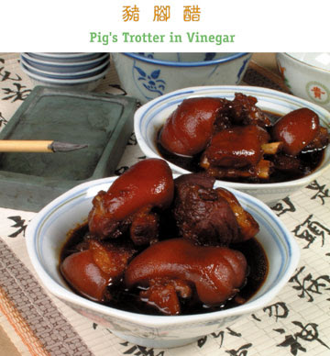

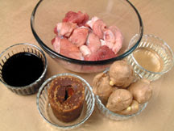

**Zhu Jiao Chu (Pig's Trotter in Vinegar)**

**Ingredients:**

* 1 pig’s fore trotter (Chop into pieces)
* 150g old ginger
* Dried chillies (optional)

**Seasoning:**

* 200ml white vinegar
* 500ml black vinegar
* 180g palm sugar/ gula melaka

**Methods:**

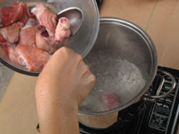

1. Clean pig’s trotter. Blanch in boiling water for 3 minutes. Remove trotter from the pot.

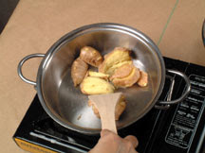

2. Wash old ginger. Smash with blade of cleaver. Put into a pot and fry lightly over low heat for a while without oil.

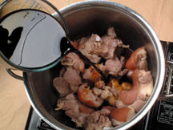 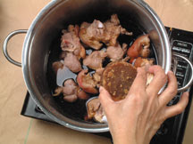

3. Put fried ginger, pig’s trotter and seasoning into a stainless steel pot or a clay pot. Boil on high heat, then turn to low heat. Simmer for 1 hour till meat is tender. Serve warm.

**Tips**: Blanching trotter in boiling water will remove any unpleasant odour and fatty scums that may surface. Extra water is not needed to cook trotter for above recipe as Yuen Chun’s range of vinegar give this dish a balanced taste.

**Indian Cuisine**

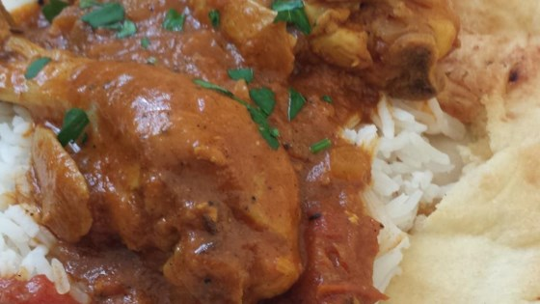

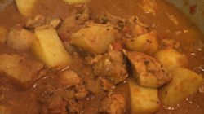 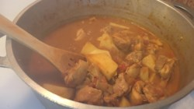

**Indian Traditional Chicken Curry**

**Ingredient:**

* 1 pound skinless, boneless chicken breast halves - cut into bite-size pieces
* 1 tablespoon fresh lemon juice
* salt and pepper to taste
* 3 tablespoons olive oil
* 1 teaspoon cumin seed
* 1 large onion, finely chopped
* 2 cloves garlic, minced
* 1 teaspoon minced fresh ginger
* 1 (8 ounce) can peeled, chopped tomatoes
* 1 teaspoon chili powder
* 1/2 teaspoon ground turmeric
* 1 teaspoon garam masala
* 1/2 teaspoon ground cumin
* 1 pinch ground coriander
* 1/2 teaspoon paprika
* 3 tablespoons plain yogurt
* 2 medium potatoes, peeled and cut into 1 inch cubes
* 1 1/2 cups water
* 1 (5.5 ounce) can tomato juice
* fresh chopped cilantro, for garnish

**Methods:**

1. In a large bowl, toss the chicken pieces with lemon juice, salt, and pepper to coat. Set aside.
2. Heat oil in a large, heavy saucepan over medium heat. Stir in cumin seed and cook 1 minute, until lightly toasted. Mix in onion, garlic, and ginger. Cook until onion is tender. Add tomatoes, and season with chili powder, turmeric, garam masala, ground cumin, coriander, and paprika. Continue to cook and stir 2 minutes.
3. Mix yogurt into the saucepan until well blended. Add chicken pieces, and potatoes. Mix in water and tomato juice. Reduce heat to medium-low. Cover and simmer about 40 minutes. Adjust seasonings to taste and garnish with fresh cilantro before serving.

**Western cuisine**

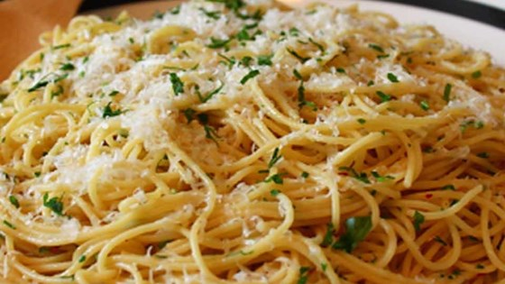

**Spaghetti Aglio E Olio**

**Ingredients:**

* 1 pound uncooked spaghetti
* 6 cloves garlic, thinly sliced
* 1/2 cup olive oil
* 1/4 teaspoon red pepper flakes, or to taste
* salt and freshly ground black pepper to taste
* 1/4 cup chopped fresh Italian parsley
* 1 cup finely grated Parmigiano-Reggiano cheese

**Methods:**

1. Bring a large pot of lightly salted water to a boil. Cook spaghetti in the boiling water, stirring occasionally until cooked through but firm to the bite, about 12 minutes. Drain and transfer to a pasta bowl.
2. Combine garlic and olive oil in a cold skillet. Cook over medium heat to slowly toast garlic, about 10 minutes. Reduce heat to medium-low when olive oil begins to bubble. Cook and stir until garlic is golden brown, about another 5 minutes. Remove from heat.
3. Stir red pepper flakes, black pepper, and salt into the pasta. Pour in olive oil and garlic, and sprinkle on Italian parsley and half of the Parmigiano-Reggiano cheese; stir until combined.
4. Serve pasta topped with the remaining Parmigiano-Reggiano cheese.

**Own recipe**

**Chinese Cuisine**

**Zhu Jiao Chu**

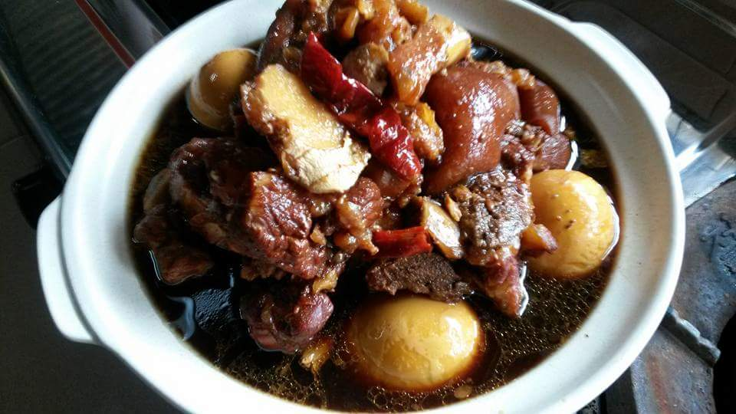

**Ingredients:**

* 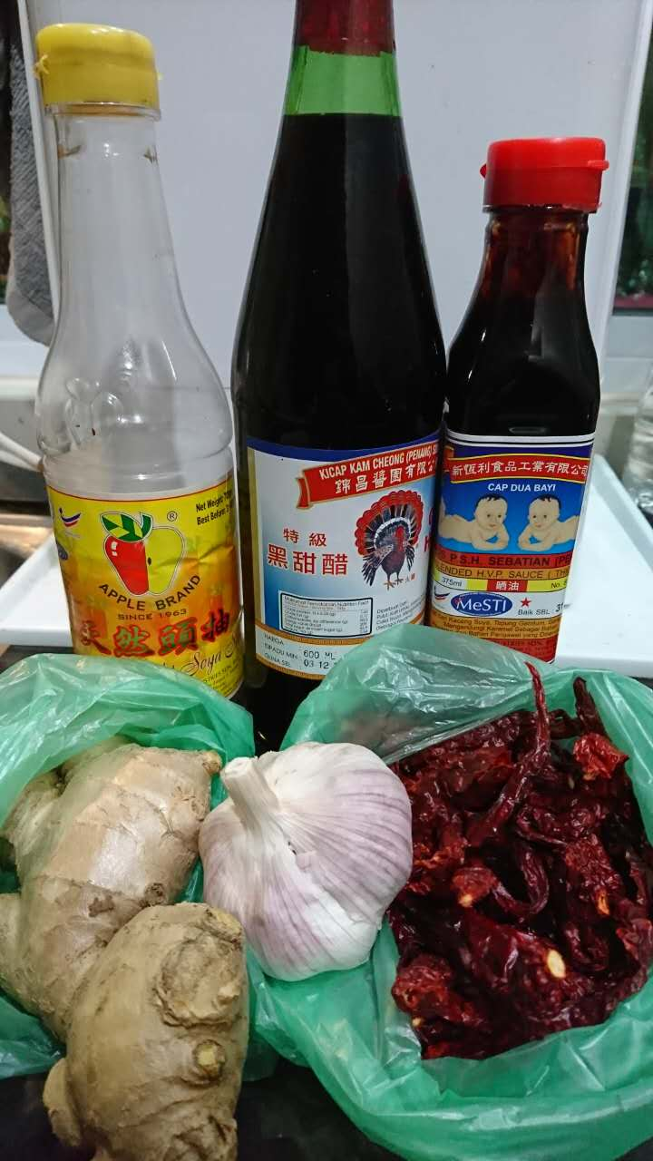2 kg pig’s trotters (hind legs), chop into smaller pieces
* 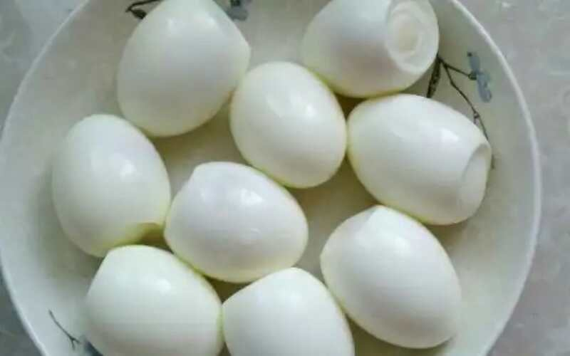150g ginger
* 600ml Black vinegar
* 2 tablespoons oil
* 2 tablespoons soy sauce
* 1 tablespoons black soy sauce (thick)
* 80g brown sager or 1 piece of Gula Malacca
* 10 to 15 dry red chili
* 1 whole garlic
* 8 to 10 hard boil eggs

**Methods:**

1. 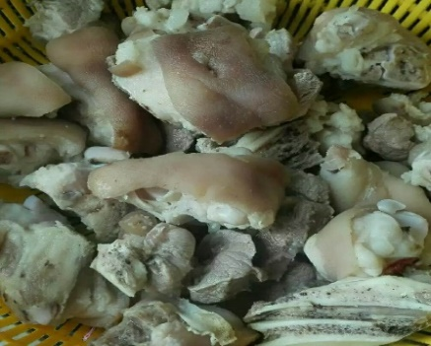Wash pig’s trotters. Blanch them in boiling water for about 5 to 10 minutes to remove excess blood. Remove and rinse with water and set aside.
2. Heat the oil over medium. Add pig’s trotter and fry 10 minutes. Add ginger and dry red chili; stir fry another 5 minutes until fragrant.
3. Pour vinegar, black soy sauce, soy sauce, whole garlic and sugar into the pot and bring to a boil. Lower the heat and cover. Simmer for about 15 minutes.
4. Heat remaining on lower. Add hard boil eggs. Cover and simmer 1 hour. More soften of the meat more taste better and more flavors.
5. Lastly, serve with plain rice and cucumber (depending on personal’s taste)

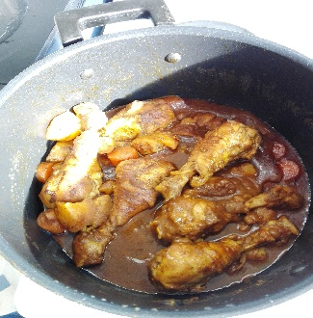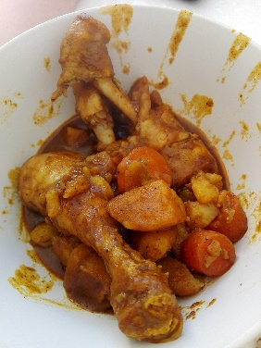**Indian Cuisine**

**Chinese Chicken Curry**

Cooking time – 45 minutes

Prepare time 10 minutes

Yield – 4 to 5 servings

**Ingredients:**

* 1 kg drumstick around 8 pieces
* 3 medium potatoes cut into cubed
* 3 carrots cut into cubed
* 1 pack of Singapore chicken curry spices (powder)
* 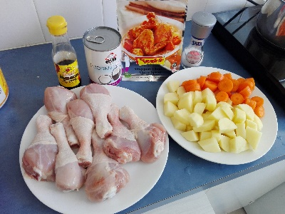2 tablespoons oil
* 1 teaspoon salt
* 2 teaspoons sugar to taste
* 2 tablespoons soy sauce
* 1 cup (250ml) coconut cream
* 4 cups (1000ml) water

**Methods:**

1. Wash drumstick and remove hair if any. Blanch them in boiling water for about 5 minutes to remove excess blood. Meanwhile to add 4 tablespoons cold water in it to cool for another 5 minutes to make the meat more tender. Remove and rinse with water and set aside.
2. Heat 2 tablespoons oil in heavy pot with high heat. Add curry powder and fry till fragrant around 1 minutes. Add water and bring to a boil.
3. Next, add potatoes and carrots. Reduce heat and cover. Simmer 10 minutes. Following add drumsticks, salt, sugar, soy sauce and coconut cream. Cover and simmer for about 30 – 45 minutes depending on how soft the meat to be and how thick you want.
4. Allow the curry to rest off the heat for 5 to 10 minutes for the sauce to be absorbed.

**Western Cuisine**

**Spaghetti Aglio E Olio**

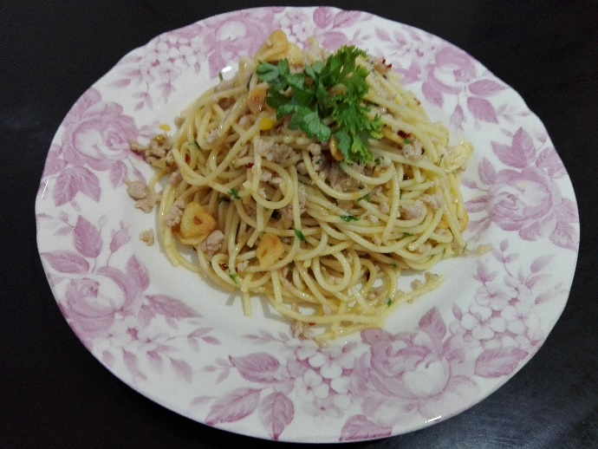

**Ingredients:**

* A packet of spaghetti (500g)
* 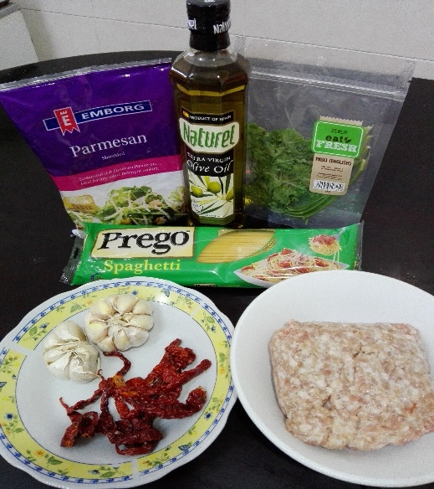2 tablespoons salt
* ½ teaspoons sugar
* 1 cup of olive oil
* 8 to 10 large garlic cloves, thinly sliced
* A few leaves of fresh Parsley
* ½ tablespoon of red pepper flakes
* 1 cup of pork mince
* 250g parmesan

**Methods:**

1. Boil water in a deep pan. Add 2 tablespoons of salt. Cook the spaghetti for 9 to 12 minutes or according to the directions on the package. Drain the pasta and keep 1 cup of the paste cooking water and set aside.
2. Use 12-inch sauce pan to heat the olive oil with medium high heat meanwhile add the garlics and cook for 2 to 3 minutes, cook until it begins to turn golden on the edges, stirring frequently to avoid overcook it.
3. Before the garlic turn into golden, add red pepper flakes and cook for 30 seconds. Following add parsley to cook for another 30 seconds, next add the cooked pasta, sugar, and cooking water to fry around 1 minute until the liquid is reduced.
4. Lastly, add the Parmesan cheese and toss will or toss until the paste is evenly coated. Serve straight away and add more grated Parmesan cheese.

**Conclusion**

In conclusion, International cuisine are important for life due to it help to promote the culture to the next generation as food is a best way to learn a culture and dining habit which by their cooking style. People eat different types of food in different countries as well as different cultures having different dining habits.

**References**

1. Y3K Recipes, 2008. Online source, Zhu Jiao Chu (Pig’s Trotter in Vinegar). Retrieve from: [**http**://y3kfreerecipes.blogspot.sg/2008/07/zhu-jiao-chu-vinegared-pigs-trotter.html](http://y3kfreerecipes.blogspot.sg/2008/07/zhu-jiao-chu-vinegared-pigs-trotter.html)
2. SimmiG. On line Source. Retrieve from: <http://allrecipes.com/recipe/80683/traditional-chicken-curry/>
3. Chef John. Online Source. Retrieve from: <http://allrecipes.com/recipe/222000/spaghetti-aglio-e-olio/>